Create Custom website and route using Route 53

Step 1:

Purchase a domain name from freenom website

Tip: Search the domain name with .ml you will get domain name quickly

Step:2:Create a instance in AWS and allow http port and run as a webserver

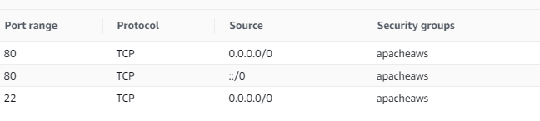

Run this Script or install by own

#!/bin/bash

sudo su

yum update -y

yum install httpd -y #apache

systemctl start httpd

systemctl enable httpd #server restart

echo "Hello AWS boys i am from $(hostname -f)" > /var/www/html/index.html

Step3:If you need to add custom webpage means deploy it in

Login to to the server and deploy in this path

/var/www/html/

Step4:Check the site using your public IP address whether you can able to access the site

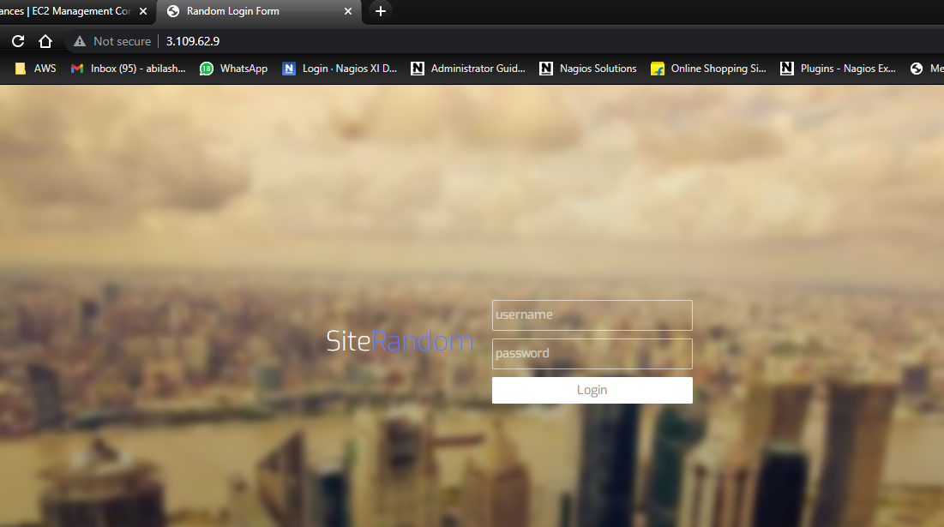

Step:5 Now it’s time to configure Route 53 and Create a hosted Zone

Step:6 Add the Custom Name servers in the freenom from Route 53

Step:7 Create a A record and give the details as below

Step 8: Now try to access your website

That’s it it works ☺

**Abilash S R**